

**Sofia Website**

*Website Description*

**Document Control**

|  |  |  |
| --- | --- | --- |
| **Editor** | **Date** | **Update** |
| **Lewis Thresh** | **03/06/2015** | **Created document + website tour** |

**Table of Contents**

1.0 Document Description 4

2.0 Website Tour 4

2.1 Homescreen 4

2.2 Shop 5

2.3 Sign Up / Log In 7

# 1.0 Document Description

This document describes the use of the sofia website and how it was created.

## 1.1 Design Process

In order to speed up the process of creating the HTML tour a template was downloaded from startbootsrap.com. This template was then adapted to suit our needs and combined with additional templates for the shop page and a login page. The homepage was then heavily adapted to show product descriptions with photoshopped pictures of the product being used by users (open source images). The shop page gave an example of how users could purchase the product along with reviews and a description. The login page was heavily adapted from an online source and was used to demonstrate how the private member section of the product would work.

The site was designed with mobiles in mind as well as desktops, as such it was created to be a responsive website. This required heavy modification of the css for all the pages and some small edits to the javascript for the login page.

# 2.0 Website Tour

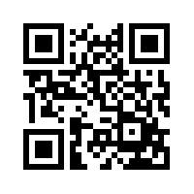

Our website can be found at sofiasoftware.github.io/, or by scanning the QR code.

## 2.1 Homescreen

The sofia website home screen displays the following image. To find out more information about the products, press the ‘**Found Out More**’ button or scroll down.



Page 1

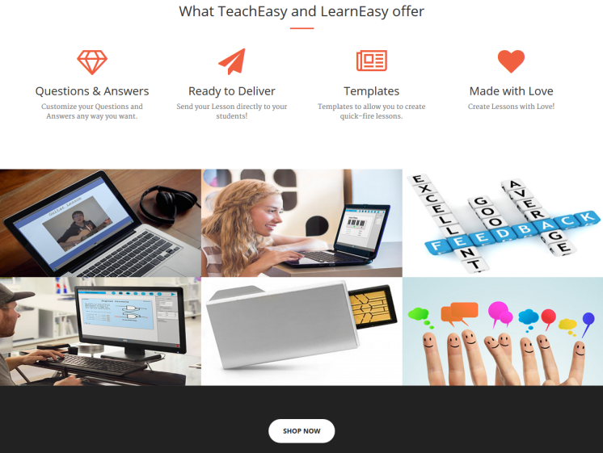

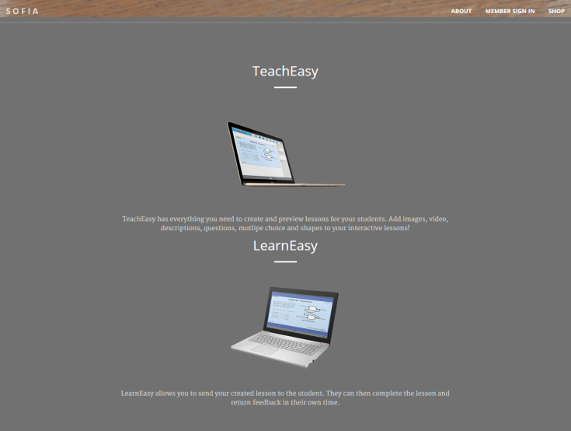

Page 2

Page 3

## 2.2 Shop

Clicking the ‘**Shop**’ tab on the top right of the website will take the user to the shop page. Here, the two different pricing packages can be found with reviews. It is possible to purchase TeachEasy for a single price of £29.99, or as a group price of £26.99 for groups of 20 or above.

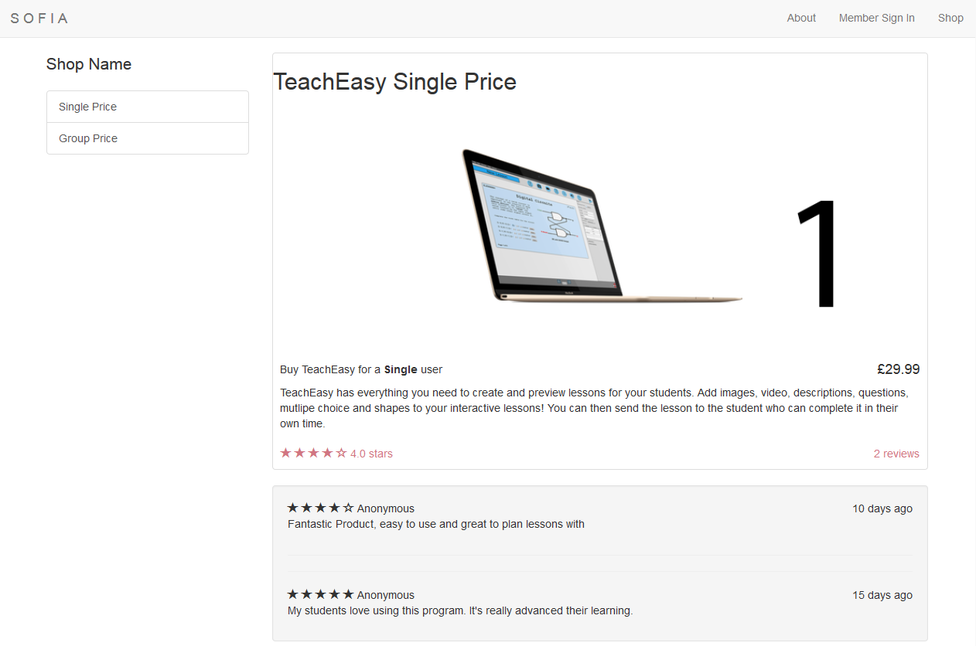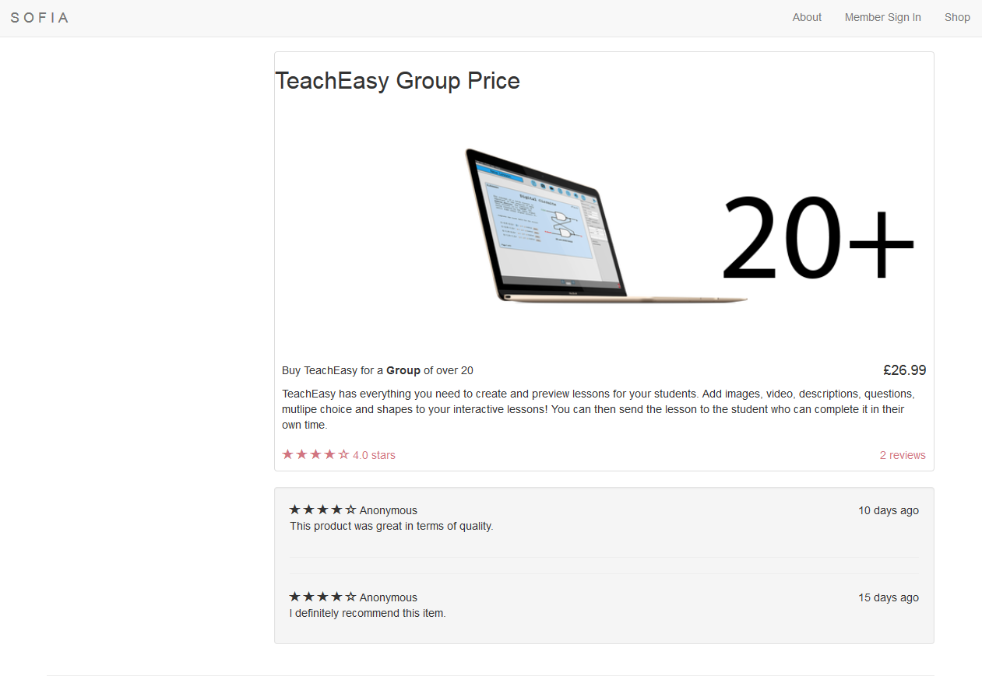

Shop Page

## 2.3 Sign Up / Log In

A teacher, tutor or student can sign up by clicking on the ‘**Member Sign In**’ tab on the top right.

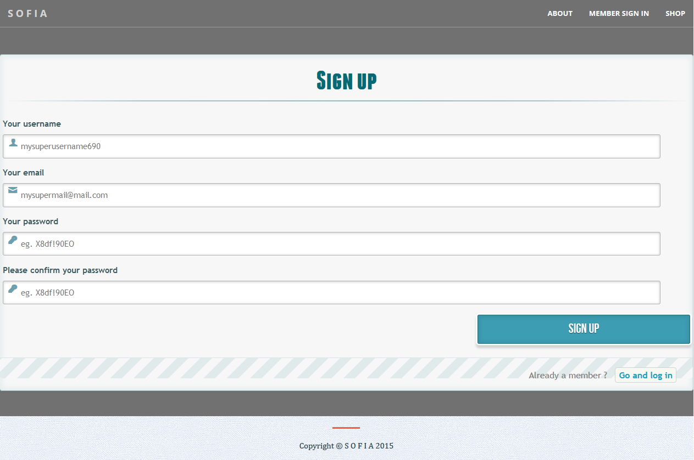

To log in, select the ‘**Go and log in**’ button on the bottom right. This will switch to the following page:

